**P5 - Produce a requirements specification for a business process**

**Introduction**

In this report, I will be explaining the requirement specification for a business process. In these terms, we will be producing a specification for the plumber. They are a number of aspects that I will be explaining for it.

**Background of organisation**

For this company, the background information about this is that the plumber works for Dull, as a junior software developer in London. This is my first assignment to complete the errors for the plumber. On this current system, manually, the plumber makes errors.

**Scope of the system/Objective**

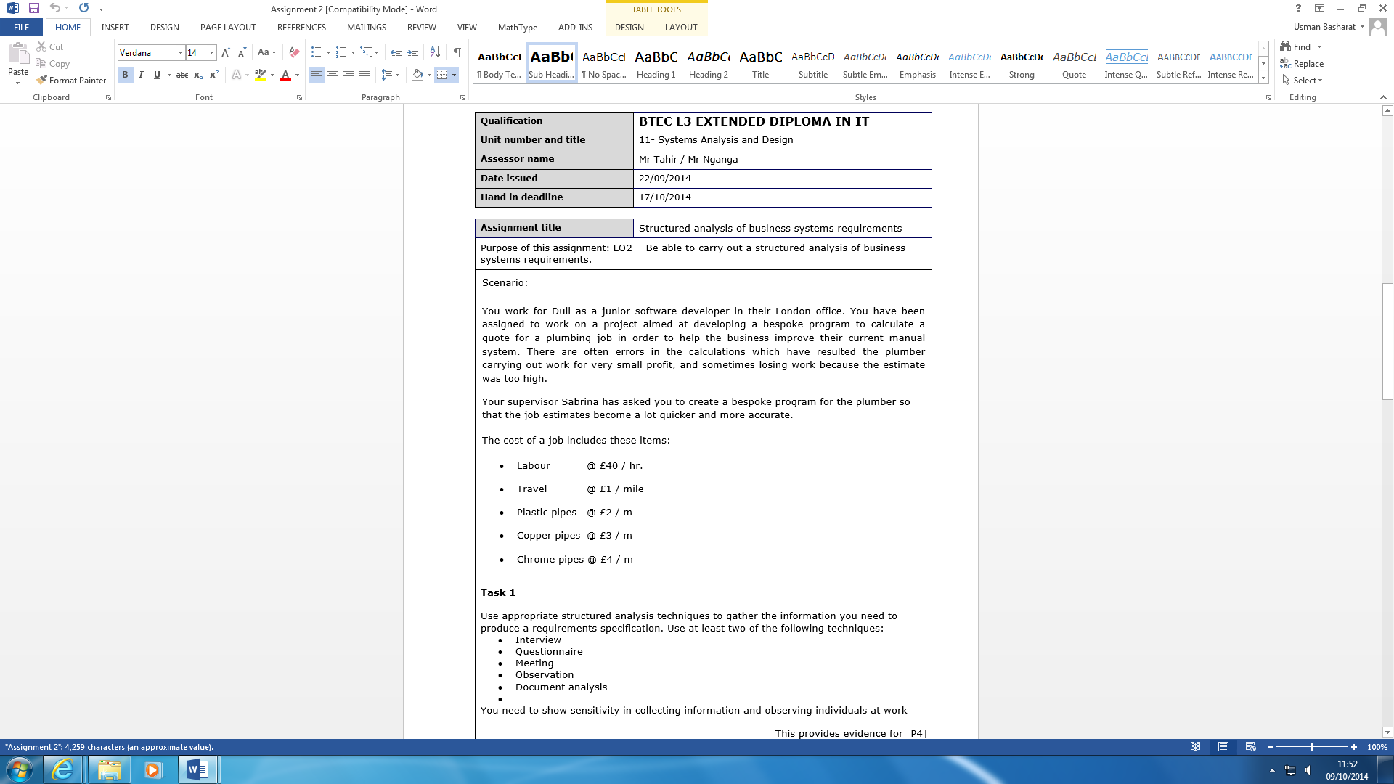The scope of the system will cover an assignment to develop a bespoke system to calculate a quote for a plumbing job. This is to help the system correct the errors that he currently has. The errors could contain very small profits, and sometime losing work. The system should make the job quicker and more accurate to get either more profits or not. The system should not create any more errors as there is no point of doing this if they are errors created. Therefore, the objective of this project is to erase the error for the plumber. The picture shows the items that would be needed for the job.

**Current System**

The current system that the plumber uses is all manual. He does not use a computer for it and does all the calculations by himself. This could complicates calculations and sheets may be lost. There is a risk of losing all the papers that he has; it could be all either burnt or lost.

**Timing**

The timing of the project is key for any new system that we are going to produce. For any project, the minimum time it takes to complete a project will be 2 years, depending on how long the system will be. Our system is not that big, e.g. IPhone 6, it will take around 1 years to create. Sometime will be needed for the feasibility study, to analyse the current system and many more for it to be suitable to start. Ideally, it will be around 6 months to do this.

Start Date: 10/10/14

Date finished: 10/10/15

**How it works?**

|  |  |  |
| --- | --- | --- |
| ***Input*** | ***Process*** | ***Expected Output*** |
| The input that is included within the system would be for the user to include what he needs to calculate. For example, 10 pipes and hammer. He can include it to the system, it would process it and the output would be complete.  The following will include what is included in the input process:   * ***Services*** *–* The services will include bookings to be made for any company. In this case, it is for a plumber. * ***Orders*** *–* The orders will need to the correct on when they ordered it. | The process would be for the calculations to be complete. This would erase any errors that the plumber has.  The following will include what is included in the process:   * ***Sorting it out*** – Any order needs be dated correctly, and the complete calculations to go with it. * ***Email*** *–* The user can keep in track with the customer, in this case plumber, to update when the product will be dispatched. | The output would be the whole calculations complete. If the user has a whole list of stuff to complete, all he does is to insert it in the system and it would be easier.  The expected outcome is the following:   * ***Reports or receipts*** – This will be given to the customer stating what they have purchased. This is ideal for any returns * ***Queries:***Numbers will be stated on the receipts for any enquires they have for the product or anything else. |

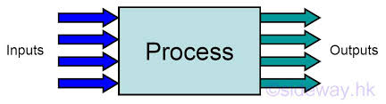

**Employees**

Obviously, we need more than one person being expert in this field. For example, if there is any problem that is necessary for this, I would call one of the employees that is expert in the world, and fix it. I will have 5 employees for this task, and they have many roles they need to know. I would want 4 of the employees being a ‘general’ one. This means they would need to know what each of the topic is. I would want the extra employee being an expert on the one that the other employees does not know about or are weak in. This would benefit the whole company.

**Softwares**

They are many softwares he will use and they are the following:

* Microsoft Office 2010
* Microsoft Visual Studio 2010
* Norton Anti-Virus 2013

**-Microsoft Office 2010**

As he does not have this system, I will recommend him to purchase this. Office includes several of programs within for it to be suitable. Microsoft Office 2010 is used for this system because if any document that he needs to complete, he will need to use Microsoft Word for it to be complete. Excel could be used for him to be organised. For example, he can create a spreadsheet of how he is doing for himself. Many of the other program could be used for several of reasons and it is important he has this software.

**-Microsoft Visual Studio 2010**

Microsoft Visual Studio 2010 is used to make the actual program. All the codes will have to be filled in to make it. Maintaining the program will be important as well. Therefore, any mistakes and errors the user finds for the user, he will need to use this program to maintain it or erase any errors.

**-Norton Anti-Virus 2013**

As any other computers, anti-virus is needed for any company. Being secure as a company is important. This is because if any malware get into the system, he would need to scan the system to get rid of it. Any PC needs to be secure to protect his files. Having backup would be sorted out as well. If anything happens to the files, backup files would be there. For example, if anyone else deletes the program, the user has a backup program file that he can use.



**Hardware**

Although the plumber has a computer and knows how to use a computer, he is not familiar with the new softwares. I will teach him how to use it. The hardware that I will include for the computer is the following:

* Windows 8
* Dell
* USB
* Dell Printer

**Windows 8**

Windows 8 is used for this company because the latest operating system offers always the new features and faster than before. Obviously, the user needs to get used to it if the is not used to the system. However, having new features for this would be a benefit. The features that Windows 8 has the new start screen, new security e.g. picture password, and new games within the system that the user can download. And, the obvious feature is it is much faster.

**Computer (Dell)**

It is important, which company the user purchases. If I recommend him an unknown company, the user would not know what to do for or how to operate it. A familiar company has features that makes it easier for the user to deal with. For example, if the user has any hardware problems, the user can go on the official Dell site and fix it.

**USB**

The main reason I recommended this is because for backup. As I have stated before, Norton does backup for you, but it is important to carry an external storage device to do your work anywhere and for security reasons. Security reasons could be the main reason.

**Dell Printer**

A printer is used because if the user needs to print out anything, he can print it out. Although the system is manual, he will need the printer if any paperwork is necessary.

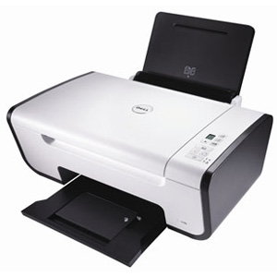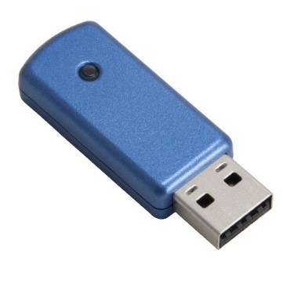

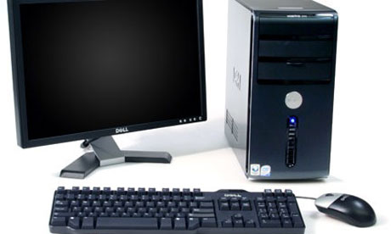

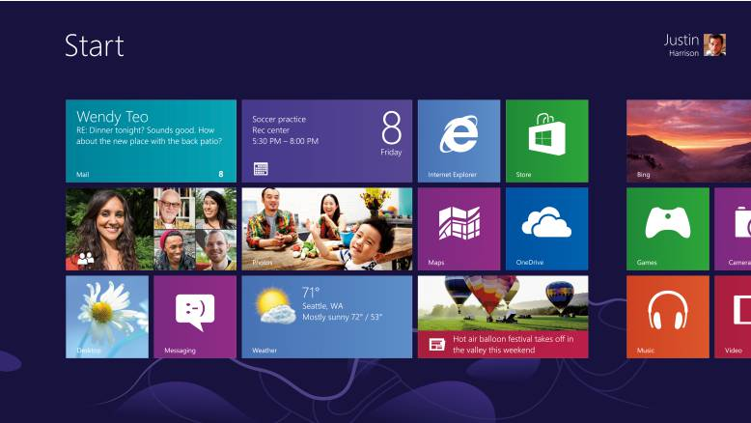

**Program**

To make it easier for the user, I will convert the current manual system to a computerised one. To confirm, the user has got a PC to use, but not often. As he is not a daily user of computers, I will give him a sheet of how to maintain the program as they are many benefits of doing this particular task. Once I have made the program, I will make sure that he knows, for sure, to use the program. He will keep a guide on Microsoft Excel of which invoice, input and output is going on in the business to keep it organised.

**Any improvements?**

Any improvements could be changed if the user asks to. If he feels as if the computer is running in a different format, and does not know how to change it, he can tell me and I can change it for him. Improvements come along once the user has a feel of the program and computer.

**Budget**

It is important how much the budget is held for the company. The minimum budget that I will be holding for this company will be around £1000. This will cover and if it does not cover it, I will cover the cost of it. For example, the user needs to fill the user’s needs. For the needs to be fulfilled, the company needs to add the features of it.

Budget: £1000+

**Storage**

This is the hardware storage for the computer. 4GB would be enough for the user to cover all his documents. If any problems occur, he could either extend it by using extended storage devices or delete any unnecessary files that he does not need. The user needs a lot of storage because they will be many files he would save and update for it. 4GB would allow doing it several times. For USB, the user can choose any storage if he feels it is necessary. 8GB would be more than enough to save any extended files he can use.

**Customer Details**

Details for any company is necessary. He can put the details on paper if he feels it is the better option. However, if the user feels that he computerised is better, he can do it by using Microsoft Excel. You can do this by creating subheadings for each of it e.g. address, name, area. Having these details, the plumber can refer back to it repeatedly.

**Security**

Securing the network is one of the biggest factors that needs to be maintained out of the entire network, not mentally (within the computer), but physically. The user can use many softwares that the user can use to protect the inner layer of the network. For example, if any malware enter the network, the anti-virus would need to act fast enough for the malware not to make damage. Essentially, the anti-virus removes it and removes any highly virus that enters the user. In addition, if any person is trying to enter the network, it is blocked, as there is a password for the user to enter. Without the unique password, the user cannot enter the password.

**Reference**

* [**http://www.teach-ict.com/as_a2_ict_new/ocr/A2_G063/331_systems_cycle/specifications/miniweb/pg3.htm**](http://www.teach-ict.com/as_a2_ict_new/ocr/A2_G063/331_systems_cycle/specifications/miniweb/pg3.htm)